Pin # | Function
1 | Injector 1 - Pin 1/2
2 | Injector 2 - Pin 1/2
3 | Injector 3 - Pin 1/2
4 | Injector 3 - Pin 2/2
5 | Injector 4 - Pin 1/2
6 | Injector 4 - Pin 2/2
7 | Ignition 1
8 | Ignition 4
9 | Ground
10 | Ground
11 | MAP Sensor (0v-5v)
12 | Ground
13 | 5v
14 | Proto Area 1 (0.4.4b+ Flex Sensor)
15 | Proto Area 2 (0.4.4b+ Fan)
16 | 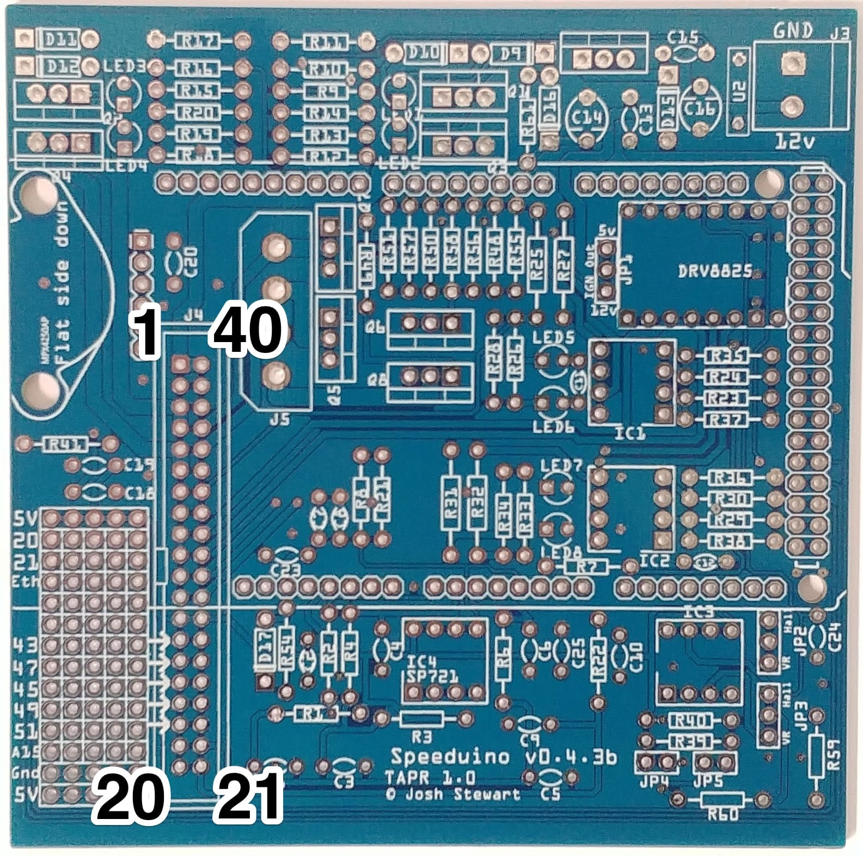  Proto Area 3 (0.4.4b+ Fuel Pump)
17 | Proto Area 4 (0.4.4b+ Tachometer)
18 | Proto Area 5 (0.4.4b+ Clutch)
19 | Coolant (CLT)
20 | Inlet Air Temp (IAT)
21 | O2 Sensor
22 | TPS input
23 | Ground
24 | Cam Input / VR2+
25 | Crank Input / VR1+
26 | VR2- (Not used for hall sensor)
27 | VR1- (Not used for hall sensor)
28 | 5v
29 | Idle Stepper 2B
30 | Idle Stepper 2A
31 | Idle Stepper 1A
32 | Idle Stepper 1B
33 | Ignition 3
34 | Ignition 2
35 | Boost
36 | Idle 2 (For use with 3 wire idle valves)
37 | PWM Idle
38 | VVT
39 | Injector 2 - Pin 2/2
40 | Injector 1 - Pin 2/2

